Maintenance Planning Task: Aircraft Rotation for Maintenance
Your Name, Lastname: ________________ School Represented: ________________
Scenario:
- YL-AAV Total Utilization on start of 05.01.2024: 1000 FC (Landings); Aircraft is located in ZRH (ACMI OUT);
- YL-AAV has maintenance (LH/RH SLAT TRACK PINIONS Special Detailed Inspection DUE 1012 FC) planned in RIX on 07-08.01.2024 night.
Objectives:
- Which flights should be changed to return YL-AAV from ZRH to RIX (Maintenance on 07-08.01.2024)
- How many FC will be left as a reserve for maintenance (07-08.01.2024 night): Minimum – Maximum number;
- Which options is better / why?
Instructions:
- Familiarize yourself with the flight schedule (Images from NetLine/OPS++ below);
- Find / evaluate stations where rotations can be performed (Where multiple aircraft registrations stays at the same time);
- Build flights sequence on YL-AAV which will allow aircraft rotation back from ZRH station to RIX station;
- Calculate utilization (total FC) on YL-AAV on start of maintenance (07-08.01.2024);
- Calculate reserves for maintenance task on YL-AAV on maintenance start time;
- Check if flight schedule can be improved to have better aircraft utilization at the moment of maintenance start (07-08.01.2024 night).

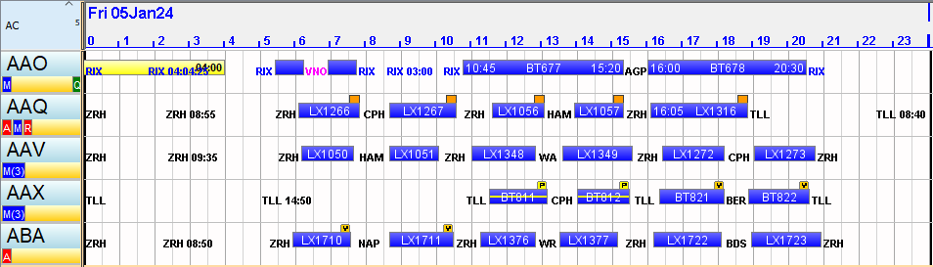
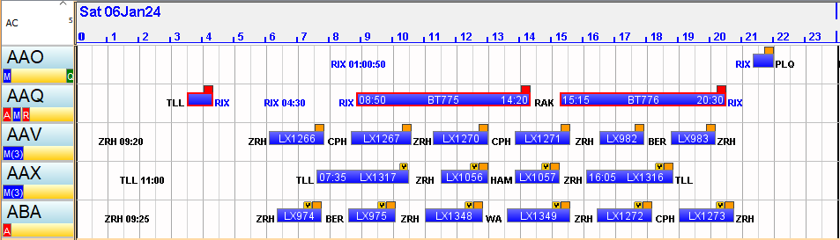
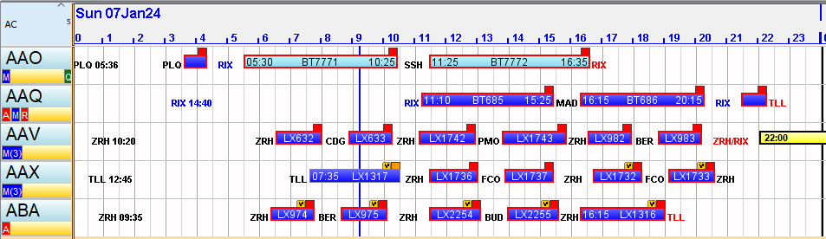

Videofaili patstāvīgiem darbiem:
https://www.youtube.com/watch?v=uxV4YpMNAsg - Gaisa kuģu kapitālais remonts

https://www.youtube.com/watch?v=mtw9ipT8-_4

LVT klausītāju viena no Patstāvīgā darba Maintenance Planning Task: Aircraft Rotation for Maintenance risinājuma “ātrajām ”versijām:
Pirmajā dienā uzreiz AAV samainās ar visām AAQ pirmās dienās lidojumiem,
vakarā AAV ir TLL,
nākošajā dienā AAV nolido AAQ pirmo reisu un tad AAV samainās AAO
un vakarā ir PLO, nākošajā dienā turpina AAO lidojumu un 16.35 ir Rīgā

